DATA ENCRYPTION AND DECRYPTION TOOL
Objective
The main objective of this project is to develop a Data Encryption and Decryption Tool that helps users securely encrypt and decrypt messages using cryptographic algorithms. The system implements AES and RSA encryption techniques to ensure data confidentiality and demonstrate practical cybersecurity concepts.

Software Requirements
• Python 3.x
• Tkinter
• PyCryptodome
• Cryptography Library
• VS Code / IDLE
• Windows Operating System

Concepts Used
• Python Programming
• Cryptography
• AES Encryption Algorithm
• RSA Encryption Algorithm
• GUI Development using Tkinter
• File Handling
• Key Management
• Data Confidentiality
• Cybersecurity Concepts

Algorithm
Step 1:
Start the application.
Step 2:
Display the graphical user interface.
Step 3:
Allow the user to select an encryption algorithm (AES or RSA).
Step 4:
Enter the message to be encrypted.
Step 5:
Click the Encrypt button.
Step 6:
Generate the encrypted text using the selected algorithm.
Step 7:
Display the encrypted output.
Step 8:
For AES, generate and display the secret key.
Step 9:
Enter the encrypted text and key (if required) for decryption.
Step 10:
Click the Decrypt button.
Step 11:
Convert the encrypted text back to the original message.
Step 12:
Display the decrypted output and execution time.
Step 13:
End the application.

Program Code
encryption_tool.py
# Main project implementation
import tkinter as tk
from Crypto.Cipher import AES, PKCS1_OAEP
from Crypto.PublicKey import RSA
from Crypto.Random import get_random_bytes
import base64
import time
# AES and RSA Encryption/Decryption Functions
# GUI Implementation using Tkinter
Sample Output
Example 1 (AES Encryption)
Input Message:
Hello World
Encrypted Output:
X8dH4f3f6Yk8P1qT9jA...
Generated AES Key:
6d7f3e8c9a1b4d5e7f8a9b0c1d2e3f4a
Encryption Time:
0.0002 seconds

Example 2 (AES Decryption)
Encrypted Message:
X8dH4f3f6Yk8P1qT9jA...
AES Key:
6d7f3e8c9a1b4d5e7f8a9b0c1d2e3f4a
Decrypted Output:
Hello World

Example 3 (RSA Encryption)
Input Message:
Cyber Security Project
Encrypted Output:
P8fVtY4rXj6sQm2K...
Encryption Time:
0.0021 seconds

Example 4 (RSA Decryption)
Encrypted Message:
P8fVtY4rXj6sQm2K...
Decrypted Output:
Cyber Security Project
Screen Shots
AES Encryption
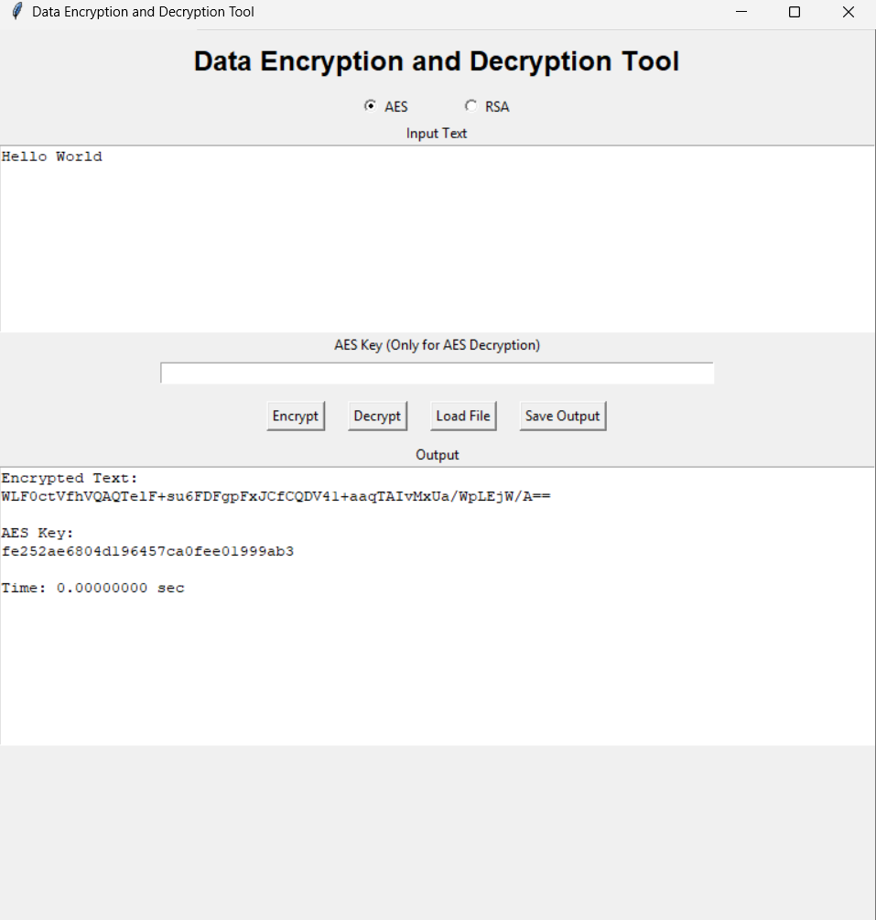

AES Decryption
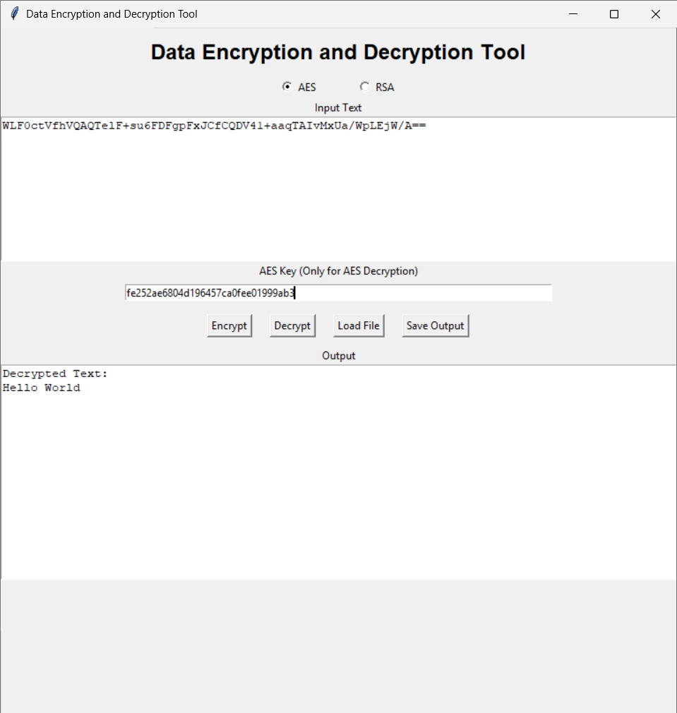

RSA Encryption
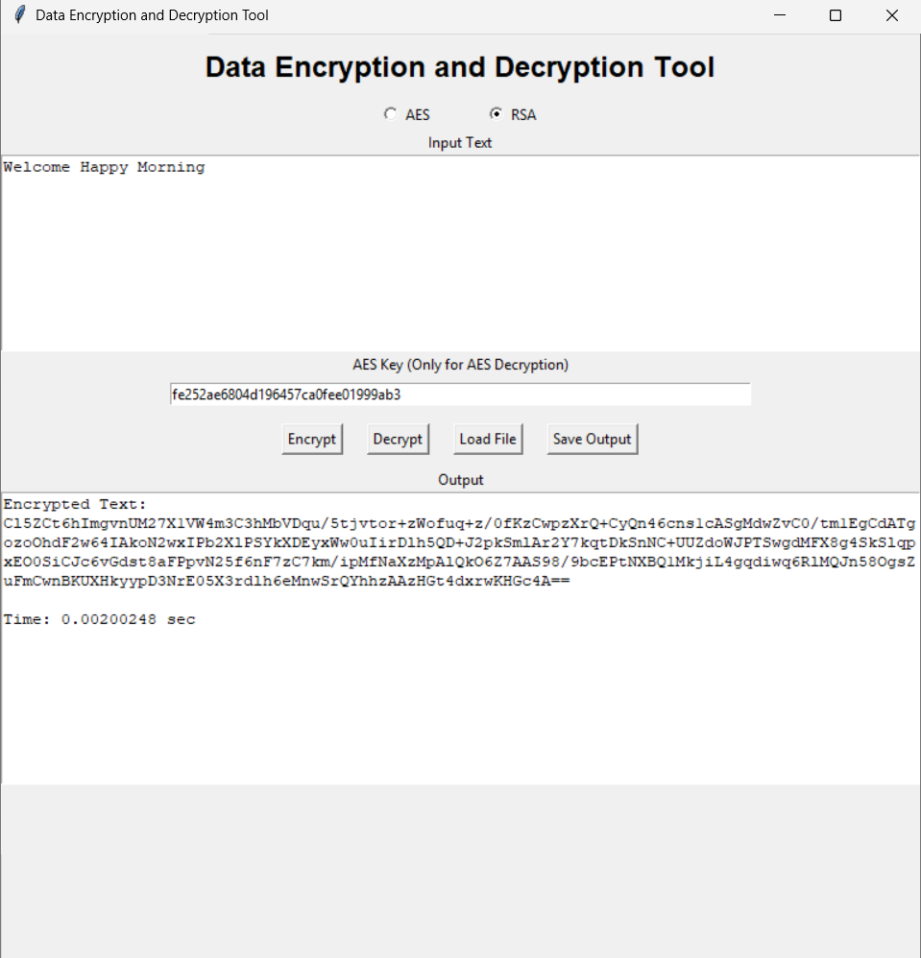

RSA Decryption
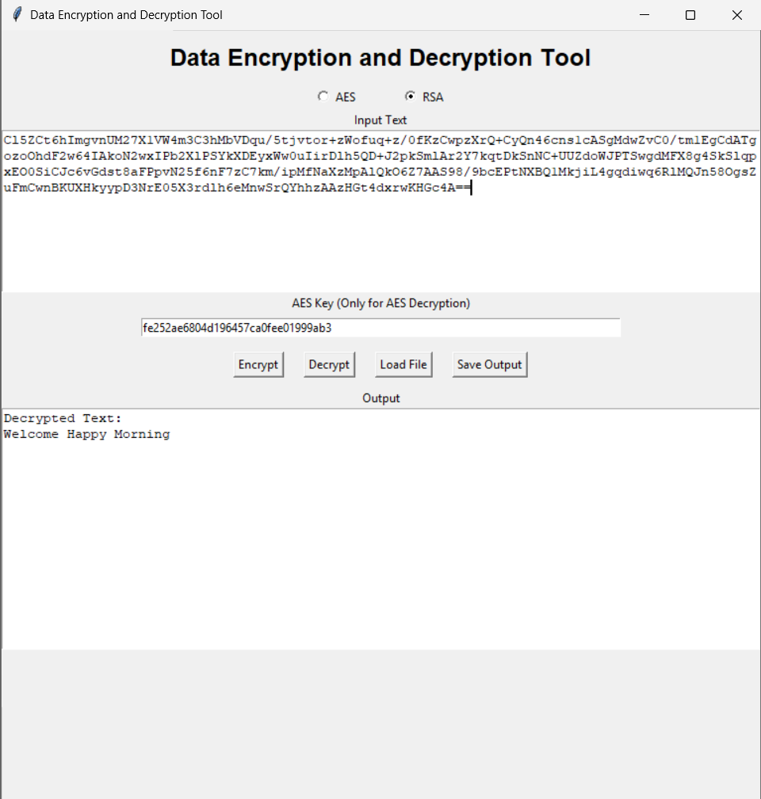

Features
• AES Encryption and Decryption
• RSA Encryption and Decryption
• User-Friendly GUI
• File Loading Support
• Save Output Functionality
• Encryption Time Measurement
• Secure Key Generation
• Performance Comparison between AES and RSA

Advantages
• Easy to use
• Provides secure data protection
• Demonstrates practical cryptography concepts
• Supports both symmetric and asymmetric encryption
• Fast encryption using AES
• Secure communication using RSA
• Useful for learning cybersecurity fundamentals

Performance Comparison
Feature | AES | RSA
Encryption Type | Symmetric | Asymmetric
Key Usage | Single Key | Public & Private Keys
Speed | Fast | Slower
Security | High | Very High
Best Use | Data Encryption | Secure Key Exchange

Conclusion
The Data Encryption and Decryption Tool successfully demonstrates the implementation of AES and RSA cryptographic algorithms using Python. The application allows users to securely encrypt and decrypt messages while understanding the practical use of cryptography in cybersecurity. The project also highlights the differences between symmetric and asymmetric encryption in terms of speed, key management, and security. Overall, this project provides valuable hands-on experience in data protection and secure communication techniques.

